
AMERICAN INTERNATIONAL UNIVERSITY-BANGLADESH (AIUB)
Department of CSE Computer Aided Design and Drafting

Section: L Room Structure
Name : Khan, Md. Sazzad Id : 22–49172-3
Supervised by : MD. RAKIBUL ISLAM CHOWDHURY

Room View:
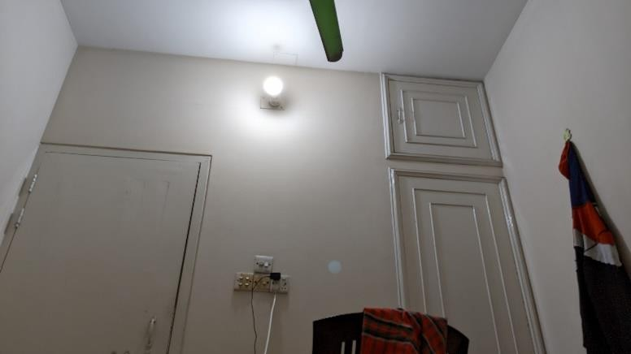
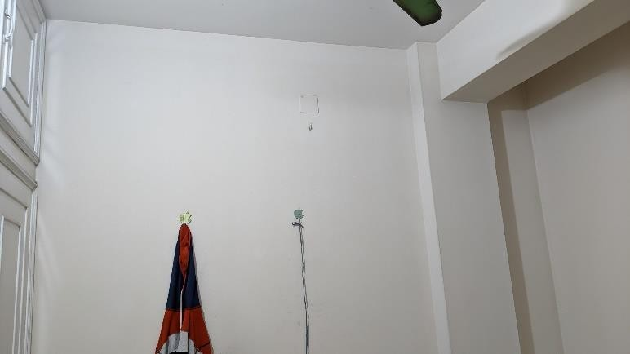

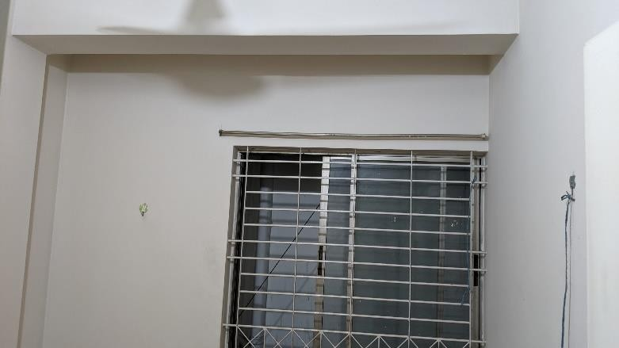
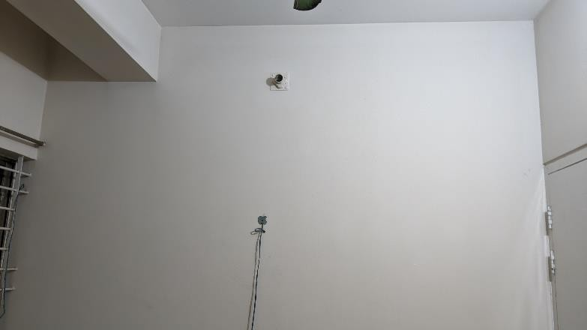

Room Structure :

